F190170 DANISH AHMED

F190228 MUHAMMAD ZAIN

F190280 MUHAMMAD AHMAD

November 19, 2021

Pharmacy Managmenmt System

Software Development Analysis

Q1: Domain Model System

# Classes:

# Domain Model Diagram:

Q2: SSD

# 1:

# 2:

# Table Description automatically generated3:

# 4:

# 5:

# 6:

3: Operational Contract

4: SDs

# SD1:

# SD2:

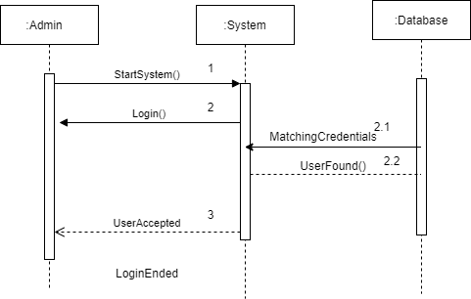

# SD3:

5: Communication Diagram

